**Group Assignment**

**Finance & Risk Analytics**

**Post-Graduate programme in Data Science & Business Analytics**

**Batch-October 2019.**

**By: Group 4**

**Indu Mohan**

**Nishitha Ramesh**

**Investment Portfolio**

**Problem Statement:**

**“You are an Equity fund manager focusing in large cap shares, your client has approached you and expressed in interest in building a portfolio of INR 1 Crore, in high quality blue chip shares.**

His criteria for investment is the investment universe is only blue chip shares (share should be part of Sensex) and he would like to invest only in 5 shares among this universe. With maximum exposure of 30% in a single share.

He has requested you to provide various portfolios with various scenarios.

**Data Source:**

**BSE India**

**Data for the past 2 years i.e., from 1-Jan-2018 to present can be directly accessed from the tickers.**

**Let us consider the Top 10 companies[1] by weightage from BSE 100 index. The list is in order from high weightage to Low.**

* **HDFC**[**Bank**](https://indiancompanies.in/largest-banks-in-india-by-market-capitalization-list/)**Ltd**
* [**Reliance Industries**](https://indiancompanies.in/about-reliance-industries/)**Ltd**
* **Housing Development Finance Corp**
* [**Infosys Ltd**](https://indiancompanies.in/infosys-limited-ceo-founder-chairman-owner/)
* **ICICI**[**Bank**](https://indiancompanies.in/largest-banks-in-india-by-market-capitalization-list/)**Ltd**
* **Tata Consultancy Services Ltd**
* [**Hindustan Unilever**](https://indiancompanies.in/hindustan-unilever-limited/)**Ltd**
* **Kotak**[**Mahindra**](https://indiancompanies.in/mahindra-group-listed-companies-chairman-ceo/)**Bank Ltd**
* [**ITC Ltd**](https://indiancompanies.in/itc-limited-products-chairman/)
* **Larsen & Toubro Ltd**

**Few important terminologies from the point of view of analyzing this case study are as follows.**

**Blue Chip shares**

**A blue-chip stock[2] is a huge company with an excellent reputation. These are typically large, well-established and financially sound companies that have operated for many years and that have dependable earnings, often paying dividends to investors. A blue-chip stock typically has a**[**market capitalization**](https://www.investopedia.com/terms/m/marketcapitalization.asp)**in the billions, is generally the**[**market leader**](https://www.investopedia.com/terms/m/market-leader.asp)**or among the top three companies in its sector, and is more often than not a household name. For all of these reasons, blue-chip stocks are among the most popular to buy among investors.**

**Value At Risk (Var)**

**Value at Risk (VaR)[3] is a financial metric that estimates the risk of an investment. More specifically, VaR is a statistical technique used to measure the amount of potential loss that could happen in an investment portfolio over a specified period of time. Value at Risk gives the probability of losing more than a given amount in a given portfolio.**

**Conditional Value at Risk (CVar)**

**Conditional Value at Risk (CVaR)[4] , also known as the expected shortfall, is a risk assessment measure that quantifies the amount of**[**tail risk**](https://www.investopedia.com/terms/t/tailrisk.asp)**an investment portfolio has. CVaR is derived by taking a weighted average of the “extreme” losses in the tail of the distribution of possible returns, beyond the**[**value at risk**](https://www.investopedia.com/terms/v/var.asp)**(VaR) cutoff point. Conditional value at risk is used in portfolio optimization for effective risk management.**

**Sharpe ratio**

**Sharpe ratio[5] help**[**investors**](https://www.investopedia.com/terms/i/investor.asp)**understand the**[**return of an investment**](https://www.investopedia.com/terms/r/returnoninvestment.asp)**compared to its risk.**

**Subtracting the risk-free rate from the mean return allows an investor to better isolate the profits associated with risk-taking activities.**[**The risk-free rate of return**](https://www.investopedia.com/articles/financial-theory/08/risk-free-rate-return.asp)**is the return on an investment with zero risk, meaning it's the return investors could expect for taking no risk.**

**Efficient Frontier**

**The efficient frontier[6] is the set of optimal portfolios that offer the highest expected return for a defined level of risk or the lowest risk for a given level of expected return. Portfolios that lie below the efficient frontier are sub-optimal because they do not provide enough return for the level of risk. Portfolios that cluster to the right of the efficient frontier are sub-optimal because they have a higher level of risk for the defined rate of return.**

Closing Price and Daily Returns

Closing price indicates the price at which the stocks were closed on a trading day.

Daily returns on the stock are used to measure the day-to-day performance of the stock, which is the price of stocks at today's closure compared to the price of the same stock at yesterday's closure.

Let’s us take a look at the trend of the Closing prices and the Daily returns from 2018.

**HDFC**[**Bank**](https://indiancompanies.in/largest-banks-in-india-by-market-capitalization-list/)**Ltd**

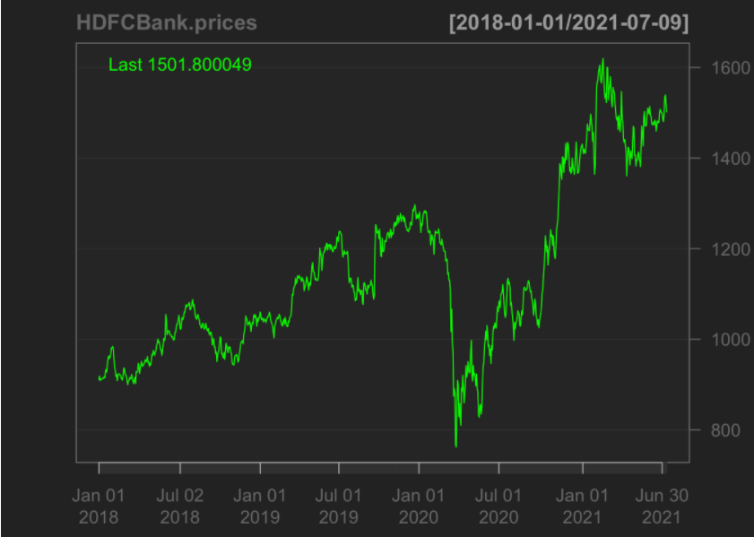 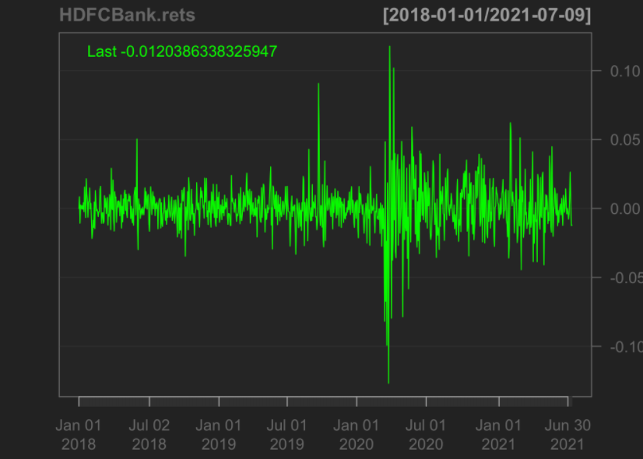

Fig1.1 Closing price of HDFC Bank Fig1.2 Daily return of HDFC Bank

Observation:

* From the Fig 1.1, it is clear that HDFC Bank Ltd stocks have a general upward trend over the years.
* There was a steep dip in the prices of the stock in the beginning of 2020 mainly because of the pandemic.
* It slowly regained the momentum by the end of 2020 and followed the upward trend
* From the Fig 1.2, we can observe that were not much fluctuations in the prices for HDFC Bank in 2018 & 2019, but in 2020, fluctuations range between -0.10 to +0.10

[**Reliance Industries**](https://indiancompanies.in/about-reliance-industries/)**Ltd**

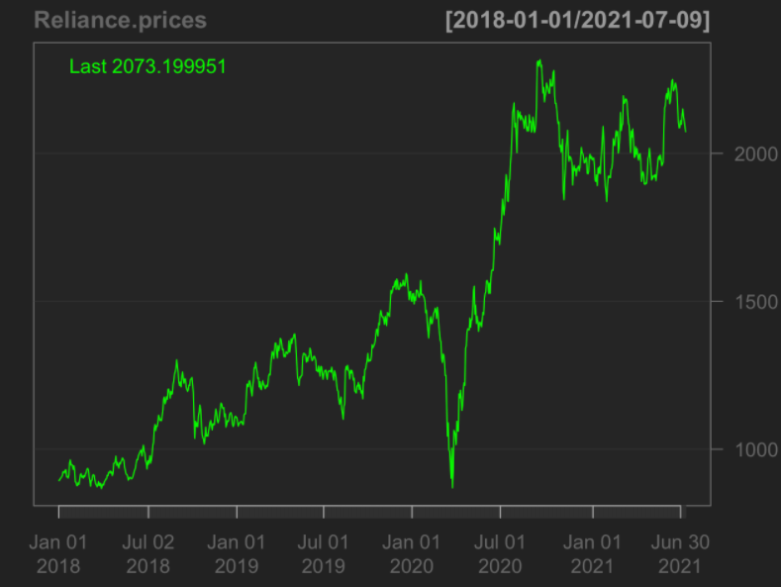 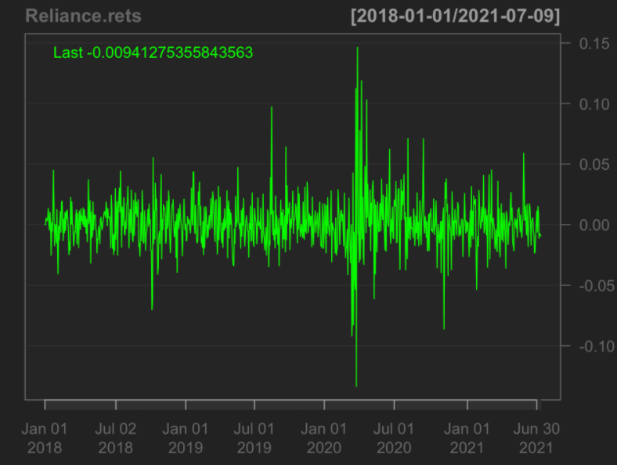

Fig2.1 Closing price of Reliance Fig2.2 Daily return of Reliance

Observation:

* From the Fig 2.1, it is clear that Reliance Industries Ltd stocks have a general upward trend over the years.
* There was a steep dip in the prices of the stock in the beginning of 2020 from 1500 to less than 1000, mainly because of the pandemic.
* It slowly regained the momentum by the end of 2020 and followed the upward trend
* From the Fig 2.2, we can observe that were not much fluctuations in the prices for Reliance in 2018 & 2019 were in the range of -0.05 to +0.05, but in 2020, fluctuations range between -0.10 to +0.10

**Housing Development Finance Corp**

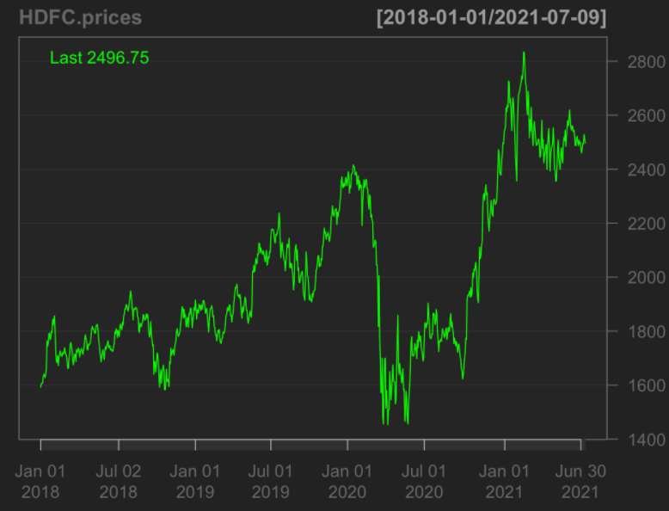 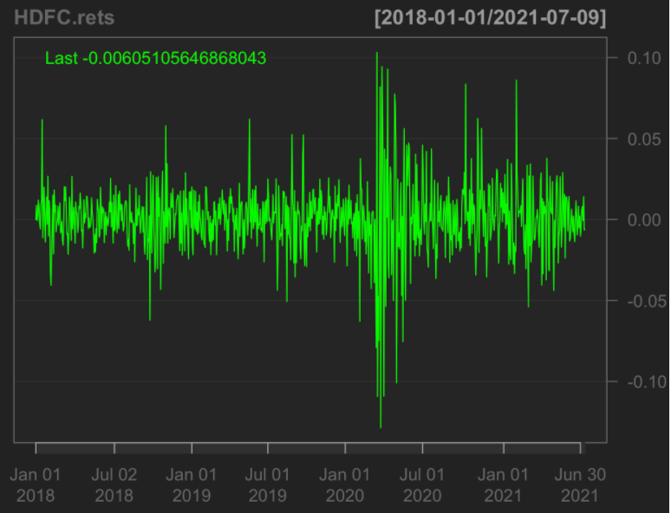

Fig3.1 Closing price of HDFC Fig3.2 Daily return of HDFC

Observation:

* From the Fig 3.1, it is clear that HDFC stocks have a general upward trend over the years.
* There was a steep dip in the prices of the stock in the beginning of 2020 from 2400 to 1400, mainly because of the pandemic.
* It slowly regained the momentum and reached a high during Jan 2021
* From the Fig 3.2, we can observe that the fluctuations in the returns were very high in 2020

[**Infosys Ltd**](https://indiancompanies.in/infosys-limited-ceo-founder-chairman-owner/)

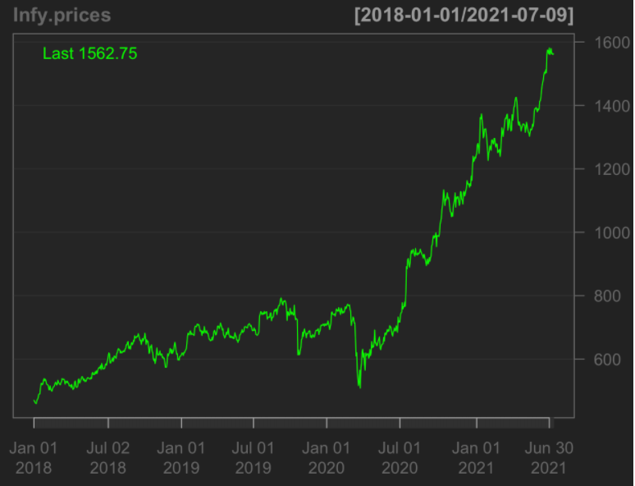 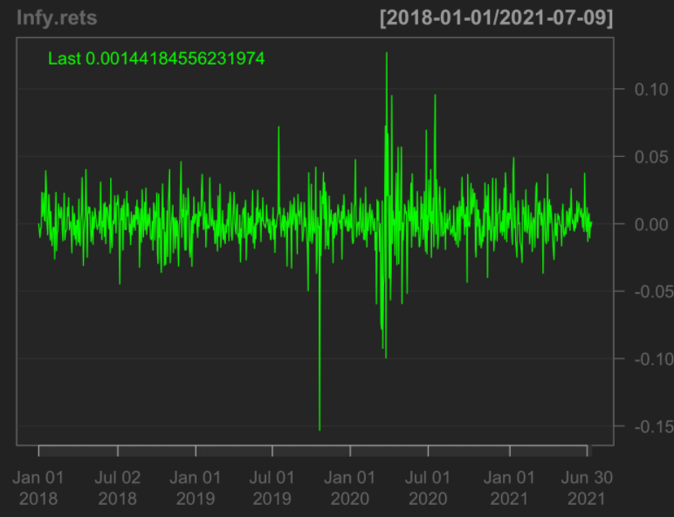 Fig4.1 Closing price of Infosys Fig4.2 Daily return of Infosys

Observation:

* From the Fig 4.1, it is clear that Infosys Ltd stocks have a general upward trend over the years.
* Interestingly, there wasn’t much of a dip for Infosys stocks in 2020 like others, though it reduced a bit.
* From Jul 2020, the stocks are in an upward trend
* From the Fig 4.2, we can observe that the fluctuations in the returns is generally less and always in the range of -0.05 to +0.05 other than in 2020

**ICICI**[**Bank**](https://indiancompanies.in/largest-banks-in-india-by-market-capitalization-list/)**Ltd**

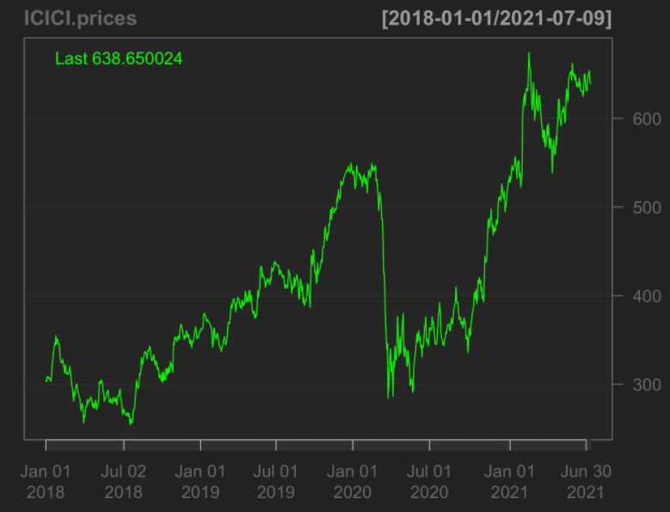 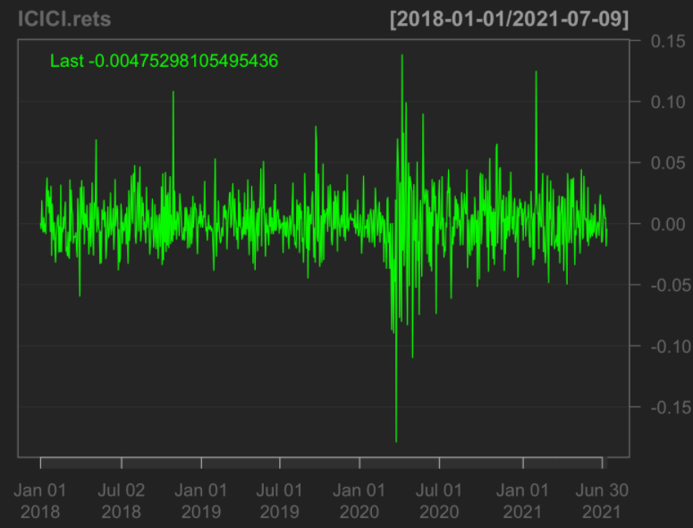

Fig5.1 Closing price of ICICI Fig5.2 Daily return of ICICI

Observation:

* From the Fig 5.1, it is clear that ICICI stocks have a general upward trend over the years.
* There was a steep dip in the prices of the stock in the beginning of 2020 from 500 to 300, mainly because of the pandemic.
* It slowly regained the momentum and reached a high during Jan 2021
* From the Fig 5.2, we can observe that the fluctuations in the returns were very high in 2020

**Tata Consultancy Services Ltd**

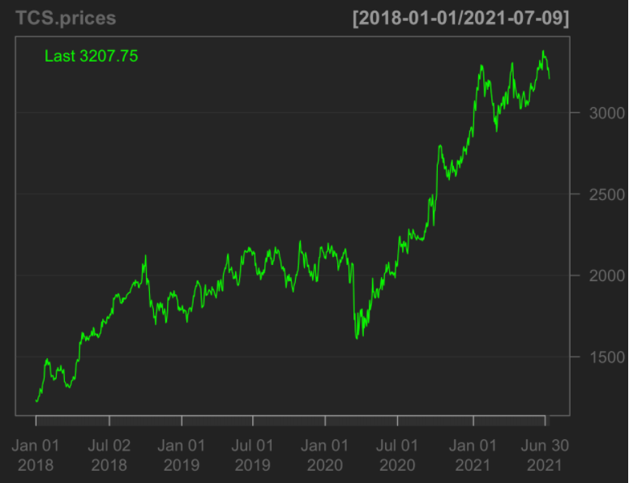 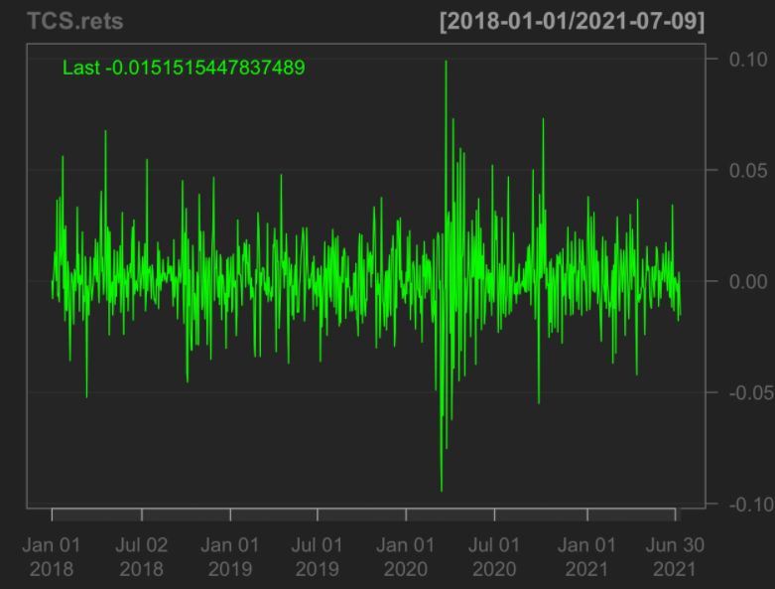

Fig6.1 Closing price of TCS Fig6.2 Daily return of TCS

Observation:

* From the Fig 6.1, it is clear that TCS Ltd stocks have a general upward trend over the years.
* Interestingly, there wasn’t much of a dip for TCS stocks in 2020 like others, though it reduced a bit.
* From Jan 2021, the stocks are in an upward trend
* From the Fig 6.2, we can observe that the fluctuations in the returns is generally less and always in the range of -0.05 to +0.05 other than in 2020

[**Hindustan Unilever**](https://indiancompanies.in/hindustan-unilever-limited/)**Ltd**

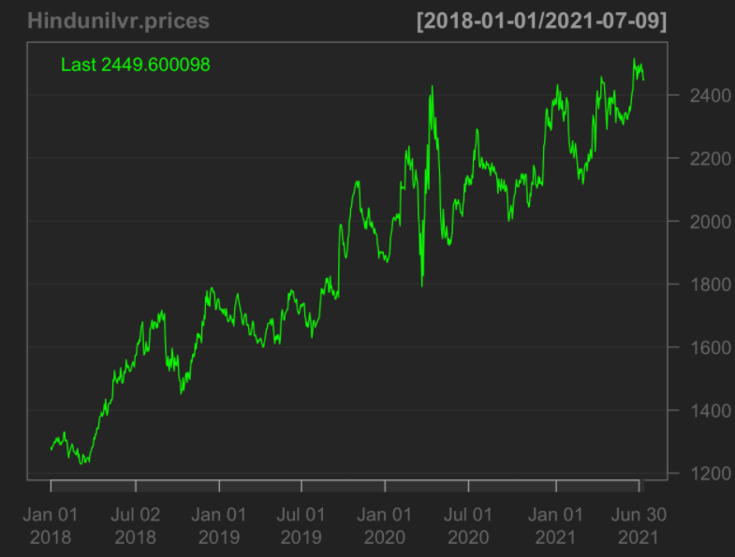 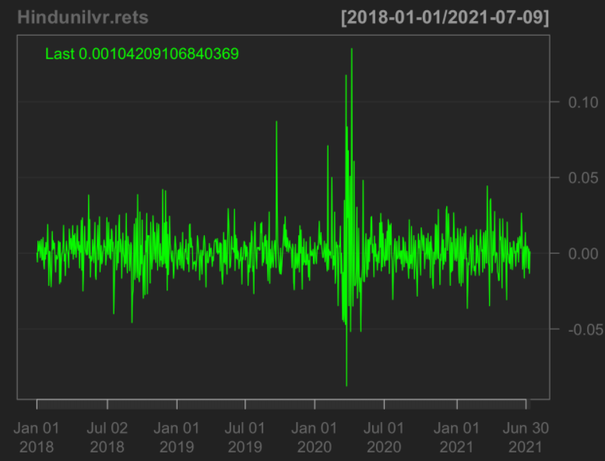

Fig7.1 Closing price of Hindustan Unilever Fig7.2 Daily return of Hindustan Unilever

Observation:

* From the Fig 7.1, it is clear that Hindustan Unilever Ltd stocks have a general upward trend over the years.
* Interestingly, there wasn’t much of a dip for Hindustan Unilever stocks in 2020 like others.
* From the Fig 7.2, we can observe that the fluctuations in the returns is generally less and always in the range of -0.05 to +0.05

**Kotak**[**Mahindra**](https://indiancompanies.in/mahindra-group-listed-companies-chairman-ceo/)**Bank Ltd**

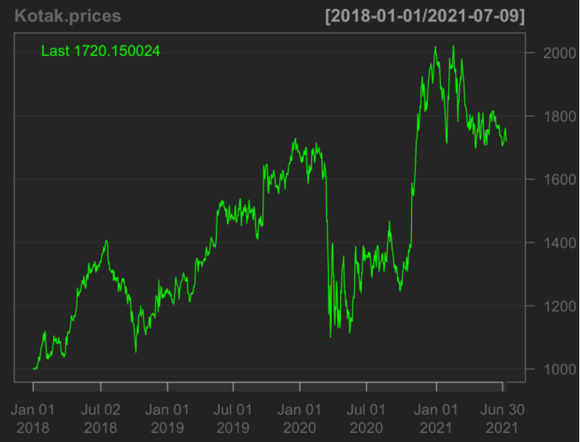 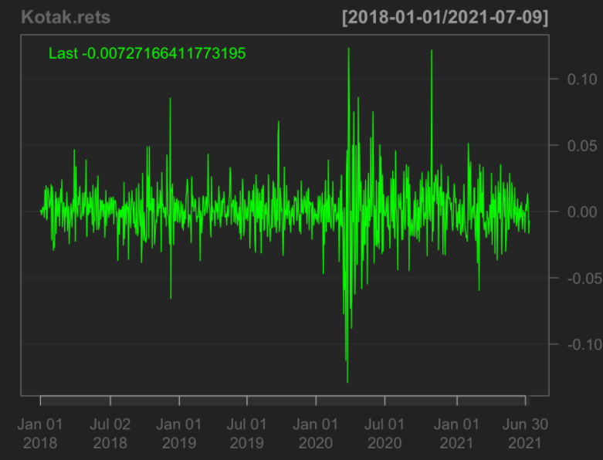

Fig8.1 Closing price of Kotak Fig8.2 Daily return of Kotak

Observation:

* From the Fig 8.1, it is clear that Kotak bank stocks have a general upward trend over the years.
* There was a steep dip in the prices of the stock in the beginning of 2020 from 1600 to 1100, mainly because of the pandemic.
* It slowly regained the momentum and reached a high during Jan 2021
* From the Fig 8.2, we can observe that the fluctuations in the returns were very high in 2020

[**ITC Ltd**](https://indiancompanies.in/itc-limited-products-chairman/)

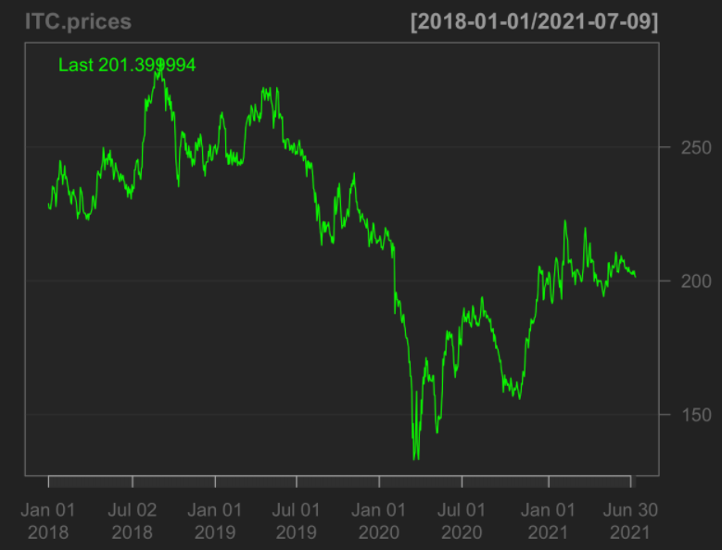 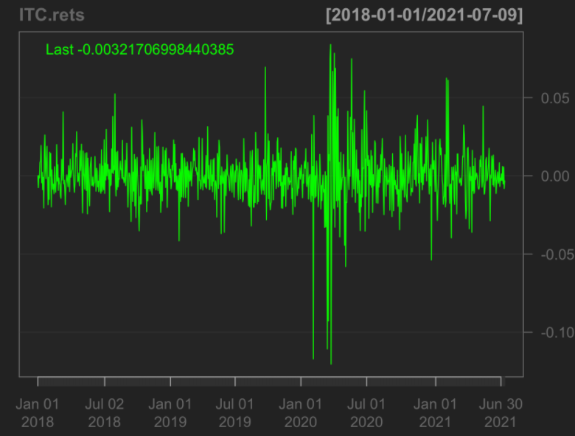

Fig9.1 Closing price of ITC Fig9.2 Daily return of ITC

Observation:

* From the Fig 9.1, it is clear that ITC stocks had a steady trend over the years.
* There was a steep dip in the prices of the stock in the beginning of 2020, mainly because of the pandemic.
* It is slowly regaining the momentum but the prices are still less when compared to its prices in 2019
* From the Fig 9.2, we can observe that the fluctuations in the returns were very high in 2020

**Larsen & Toubro Ltd**

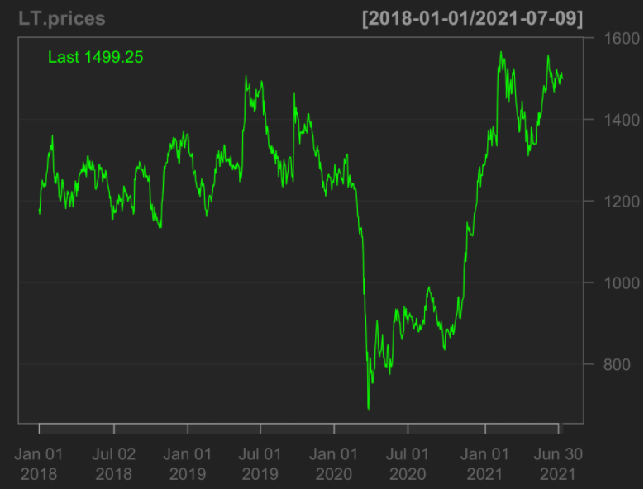 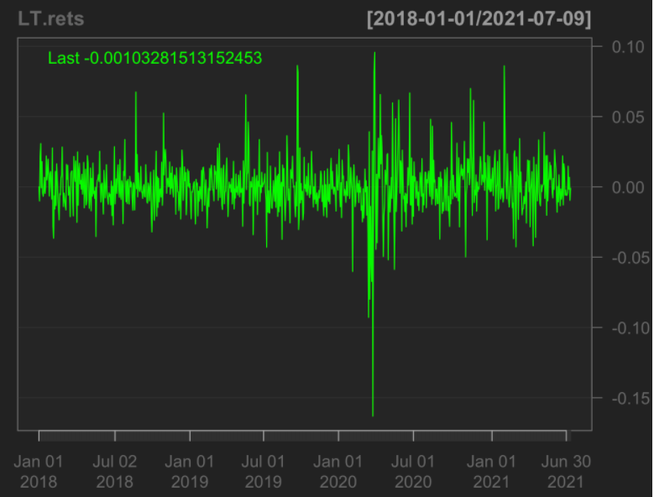

Fig10.1 Closing price of L&T Fig10.2 Daily return of L&T

Observation:

* From the Fig 10.1, it is clear that L&T stocks have a steady trend over the years.
* There was a steep dip in the prices of the stock in the beginning of 2020 from 1400 to 600, mainly because of the pandemic.
* It slowly regained the momentum and reached a high during Jan 2021
* From the Fig 10.2, we can observe that the fluctuations in the returns were very high in 2020 and also was in the range of -0.015 to +0.10 making it the stock with highest variance.

Risk and Returns are the most key features that we consider when investing into any stocks.

In order to build a portfolio and shortlist 5 stocks from these, we need to look at the stocks that would give us low risk and high returns.

Let us take a look at the Risk first for the 10 stocks, which is calculated using the Var and CVar.

Var & CVar using Historical method

Fig11.1 Output of Var using Historical method

Fig11.2 Output of CVar using Historical method

Var & CVar using Gaussian method

Fig12 Output of Var & CVar using Gaussian method

Var & CVar using Modified method

Fig13.1 Output of Var using Modified method

Fig13.2 Output of CVar using Modified method

Now, let us take a combined view at all the 3 methods of Var plotted.

Fig14 Combined view of Var plotted

**Observation:**

Hindustan Unilever has the lowest risk compared to other stocks.

ICICI Bank has the highest risk among others.

CAPM, the Capital Asset Pricing Model mainly describes the relationship between systematic risk and [expected return](https://www.investopedia.com/terms/e/expectedreturn.asp) for assets

Let us calculate the Beta for each of the 10 stocks and determine future course of action.

Beta can be driven either by the positive or negative rate i.e., Up Market or Down Market. Hence in order get a balance between them let us consider the time ratio which is given by the ratio of Beta in Up Market and the Beta in down Market

Time ratio = Beta in Up Market / Beta in Down Market

HDFC [Bank](https://indiancompanies.in/largest-banks-in-india-by-market-capitalization-list/) Ltd

[Reliance Industries](https://indiancompanies.in/about-reliance-industries/) Ltd

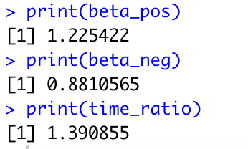

Housing Development Finance Corp

[Infosys Ltd](https://indiancompanies.in/infosys-limited-ceo-founder-chairman-owner/)

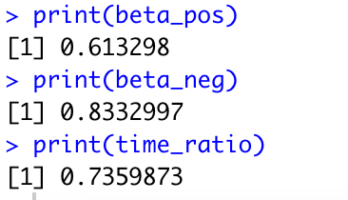

ICICI [Bank](https://indiancompanies.in/largest-banks-in-india-by-market-capitalization-list/) Ltd

Tata Consultancy Services Ltd

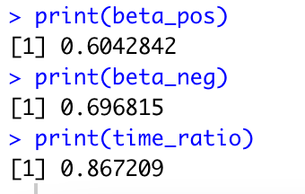

[Hindustan Unilever](https://indiancompanies.in/hindustan-unilever-limited/) Ltd

Kotak [Mahindra](https://indiancompanies.in/mahindra-group-listed-companies-chairman-ceo/) Bank Ltd

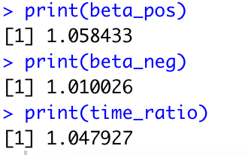

[ITC Ltd](https://indiancompanies.in/itc-limited-products-chairman/)

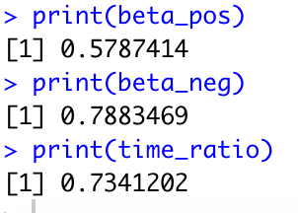

Larsen & Toubro Ltd

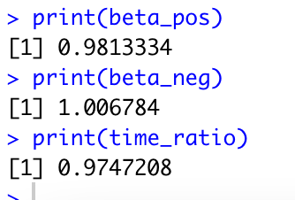

From the Var & CAPM, let us shortlist 5 stocks that have low risk and high returns.

* Hindustan Unilever has the lowest risk and provides highest return.
* Reliance provides high returns with comparably low risk.
* HDFC Bank stands the 3rd among returns and risk is also relatively low.
* TCS has low risk and returns rate is decent
* L&T also has comparatively low risk and decent returns rate.

ICIC Bank provides good returns but also is highest risk, hence not including that in our portfolio.

If we use the CAPM to perfectly optimize a portfolio’s return relative to risk, it would exist on a curve called the [efficient frontier](https://www.investopedia.com/terms/e/efficientfrontier.asp) like the below.

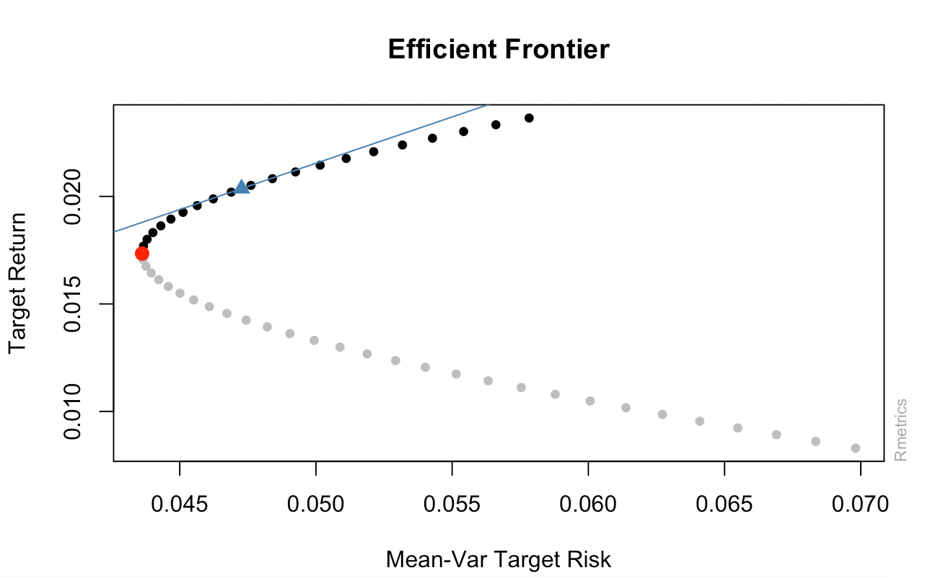

Fig15 Efficient Frontier

The graph shows how greater expected returns (y-axis) require greater expected risk (x-axis)

It provides the optimum point where the risk is lowest and the returns are maximized.

Let us take a look at the correlation of the 5 stocks selected.

From the correlation output of the 5 stocks we can observe that there is minimum correlation among the stocks, which also means that there is diversification in the portfolio.

**Different types of portfolio**

**Minimum Variance portfolio**

Minimum Variance portfolio is a portfolio that maximizes the performance while minimizing the risk. It holds volatile investment types on their own, but when combined, creates a diversified portfolio with lower volatility than any of the individual parts.

Fig16.1 Minimum Variance portfolio

As expected from the Var & CAPM, Hindiustan Unilever holds the highest weight because it had low risk and high return rate.

This portfolio is ideal for people who are not ready to take much risk and still would like to get good returns.

**Tangency Portfolio**

The Tangency portfolio represents portfolios that optimally combine risk and return. It is where risk portfolio is the market portfolio. Thus, the slope of the Tangency portfolio is the sharpe ratio of the market portfolio.

Fig16.2 Tangency portfolio

In the Tangency portfolio, TCS and Reliance has been given little higher weightage than given in the Minimum variance portfolio.

This portfolio is ideal for people who are risk lovers.

**Tangency Portfolio with Shorts allowed**

When shorts are allowed, the investor is allowed to sell the stock that he doesn’t possess, it is basically a trading contract between 2 individuals,

where they can enter into a contract for selling/buying of the stocks in the future.

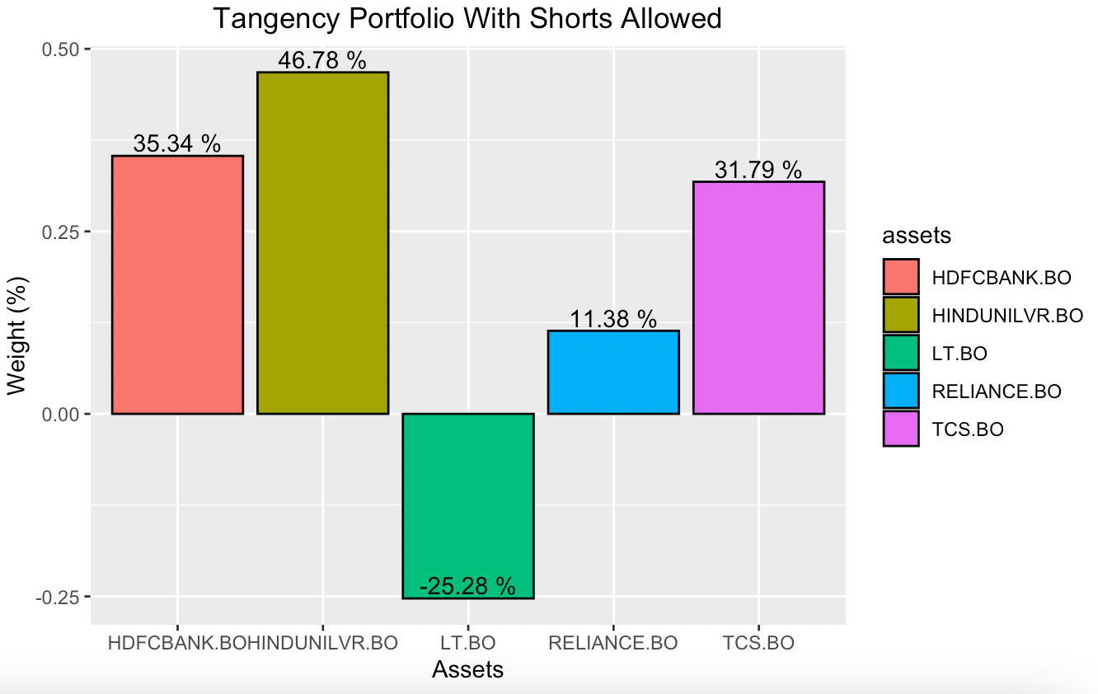

Fig16.3 Tangency portfolio with Shorts

When shorts are allowed, we can observe that the L&T stock that was given zero weightage has been given 25% for a selling contract in the future.

**Minimum Variance portfolio with manual weights given**

Manual weights given by setting only maximum up to 30% exposure in each stock.

Weights are manually optimized by comparing to the Minimum Variance portfolio model

* Hindustan Unilever had the highest weightage given by the optimized portfolio with Efficient Frontier hence set the weight of 30% to it.
* HDFC Bank had been given around 24%, hence setting that also to 30%
* L&T is given 5%

Fig16.4 Minimum Variance portfolio with Manual weights

**Tangency portfolio with manual weights given**

Manual weights given by setting only maximum up to 30% exposure in each stock.

Weights are manually optimized by comparing to the Tangency portfolio model

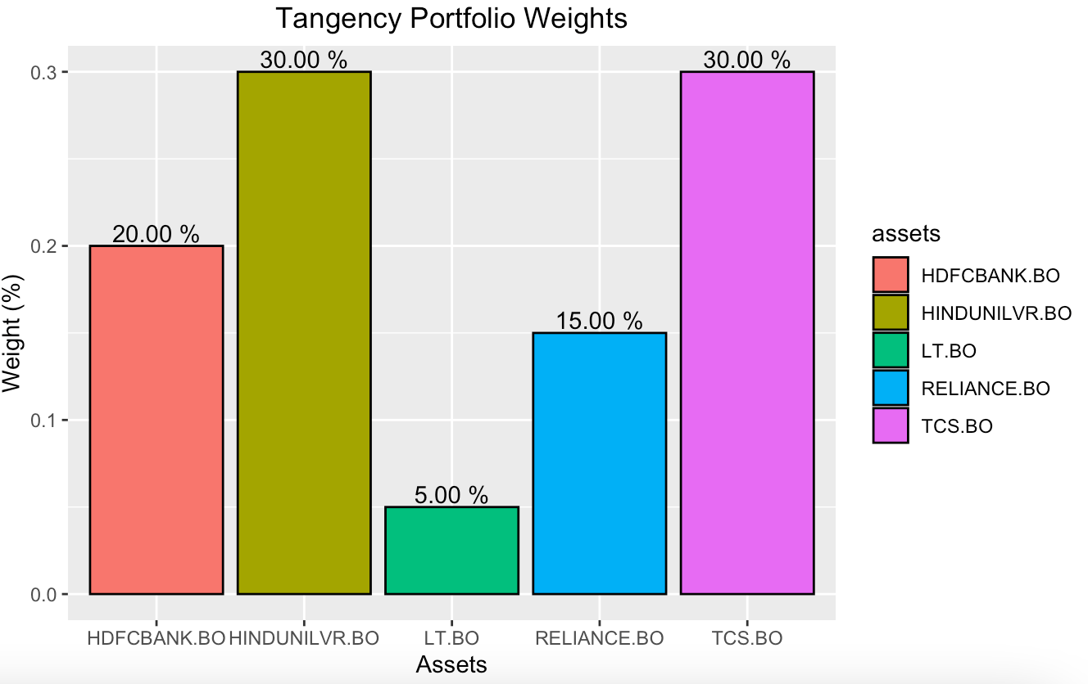

Fig16.3 Tangency portfolio with Manual weights

* Hindustan Unilever had the highest weightage given by the optimized portfolio with Efficient Frontier hence set the weight of 30% to it.
* TCS had been given around 28%, hence setting that also to 30%
* L&T is given 5%

The stocks selected have a very low correlation which also means there is good diversification in the portfolio created.

When a particular market is down at least the other ones would pull the portfolio up and thus minimizing the risk.

**References**

1. <https://indiancompanies.in/bse-100-index-list-of-stocks-companies/>
2. <https://www.investopedia.com/terms/b/bluechipstock.asp>
3. <https://corporatefinanceinstitute.com/resources/knowledge/trading-investing/value-at-risk-var/>
4. <https://www.investopedia.com/terms/c/conditional_value_at_risk.asp>
5. <https://www.investopedia.com/terms/s/sharperatio.asp>
6. <https://www.investopedia.com/terms/e/efficientfrontier.asp>